**Program 17: Demonstrate the use of exception handling keywords- try, except, raise and else**

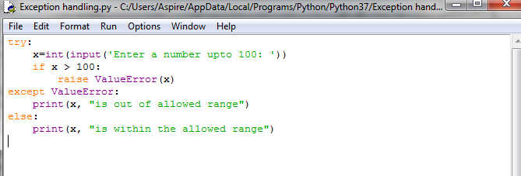

**Output:**

